What’s Best for the Children
One/ Doug
Seth Trucks
Top of Show
 | 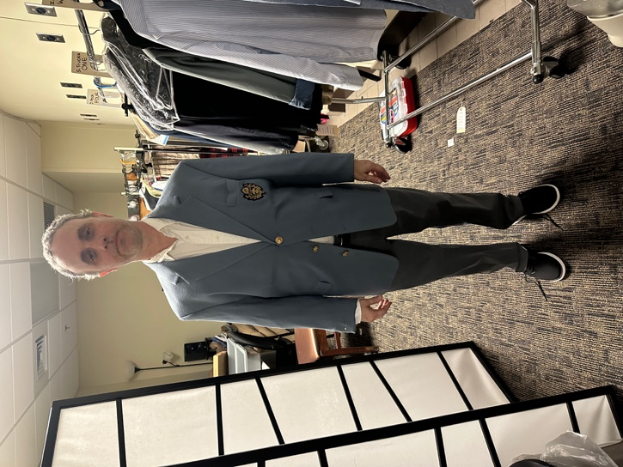
  ITEM | WASH | D.C. | HAND | N/A
  Undershirt (2) | X
  Socks (2) | X
  White Button Up Shirt | X
  Gray Blazer |  | X
  Gray Pants | X
  Belt |  |  |  | X
  Black Shoes |  |  |  | X
Doug
 | 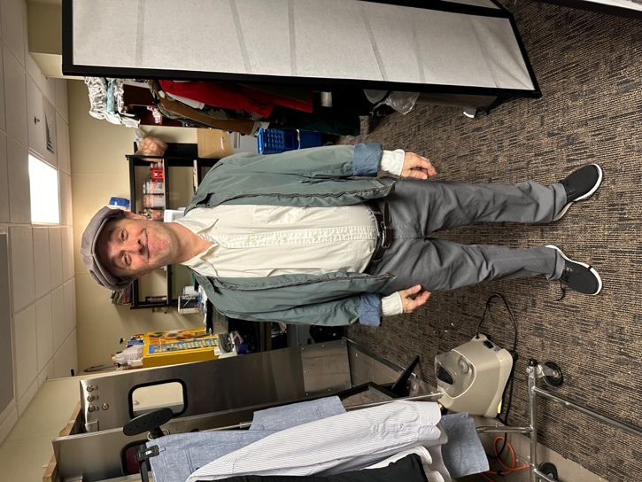
  ITEM | WASH | D.C. | HAND | N/A
  Remove Gray blazer |  |  |  | X
  Gray zip up | X
  Cap | X

Nightmare
 | 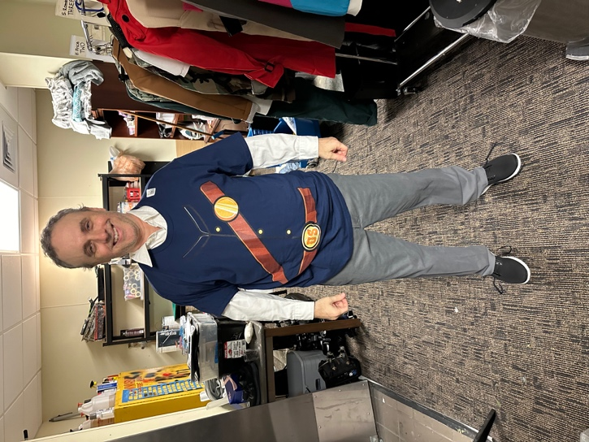
  ITEM | WASH | D.C. | HAND | N/A
  Civil War T shirt | X
Councilman Vote
 | 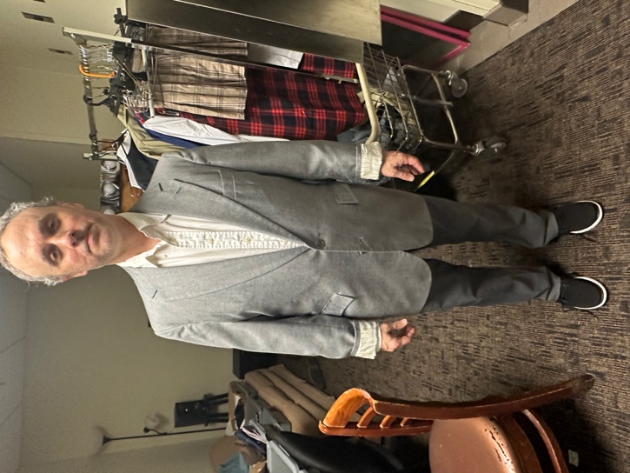
  ITEM | WASH | D.C. | HAND | N/A
  Gray Blazer |  | X

