What’s Best for the Children
Two/ D/ Kelly/ Civil War/ Student
Elizabeth Price
Top of Show
 | 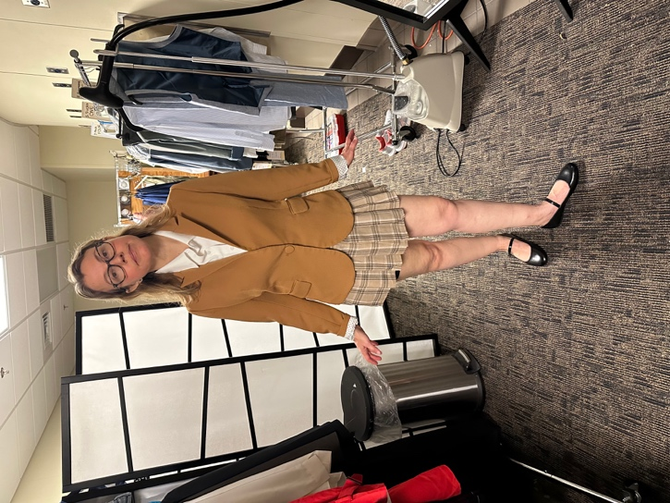
  ITEM | WASH | D.C. | HAND | N/A
  Camisols (2) | X
  Socks (2) | X
  Bike Shorts (2) | X
  Tights (2) | X
  Brown plaid skirt | X
  Brown Blazer |  | X
  Black Shoes |  |  |  | X
  White Button up shirt | X
D
 | 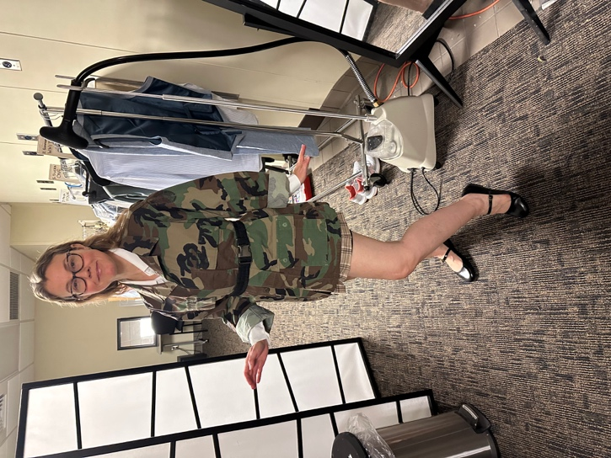
  ITEM | WASH | D.C. | HAND | N/A
  Remove Brown Blazer |  | X
  Camo Jacket | X
  Black Belt |  |  |  | X

Student
ITEM | WASH | D.C. | HAND | N/A
Remove Jacket |  | X

Nightmare
 | 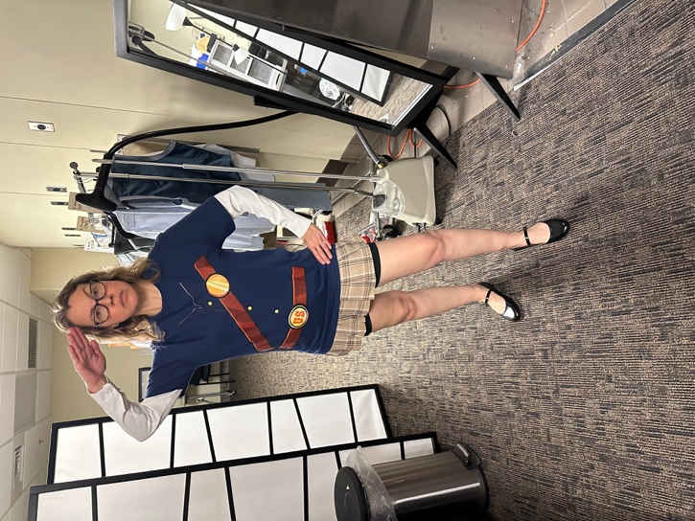
  ITEM | WASH | D.C. | HAND | N/A
  Civil War Shirt | X
Kelly
ITEM | WASH | D.C. | HAND | N/A
Remove Shirt | X
Sweatbands | X

Councilman Vote
ITEM | WASH | D.C. | HAND | N/A
Remove Shirt | X
Add brown Blazer

End of Show
ITEM | WASH | D.C. | HAND | N/A
Pink Mask | X

