What’s Best for the Children
Three/ Giztmo/Acorn
Elizabeth Price
Top of Show
 | 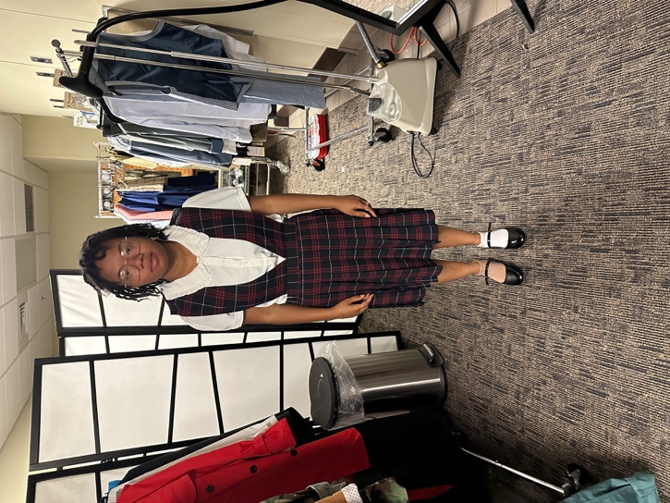
  ITEM | WASH | D.C. | HAND | N/A
  Camisols (2) | X
  Socks (2) | X
  Bike Shorts (2) | X
  Plaid Jumper | X
  White button up shirt | X
  Black Shoes |  |  |  | X
Gitmo
 | 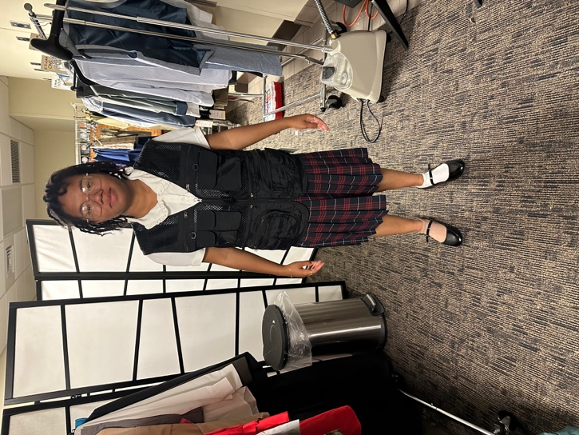
  ITEM | WASH | D.C. | HAND | N/A
  Black tactical vest |  |  |  | X
  Pink Mask

Acorn
 | 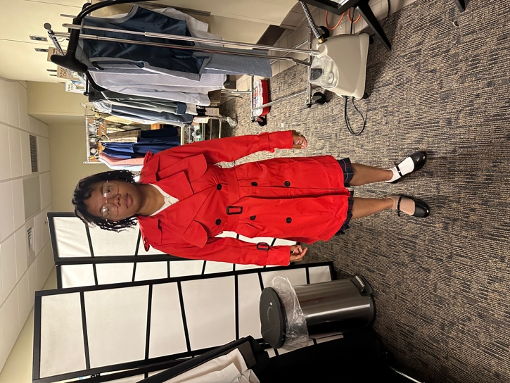
  ITEM | WASH | D.C. | HAND | N/A
  Remove Vest | X
  Red Coat | X
Nightmare
 | 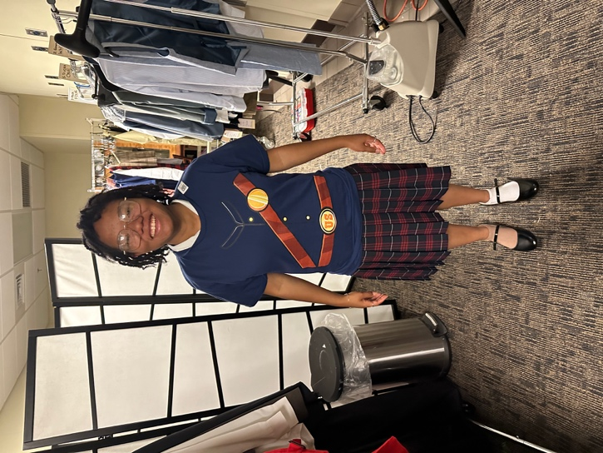
  ITEM | WASH | D.C. | HAND | N/A
  Civil War Shirt | X

Councilman Vote
ITEM | WASH | D.C. | HAND | N/A
Remove Shirt | X

End of Show
ITEM | WASH | D.C. | HAND | N/A
Pink Mask | X

