What’s Best for the Children
Four/Chris/Kelley
Elizabeth Price
Top of Show
 | 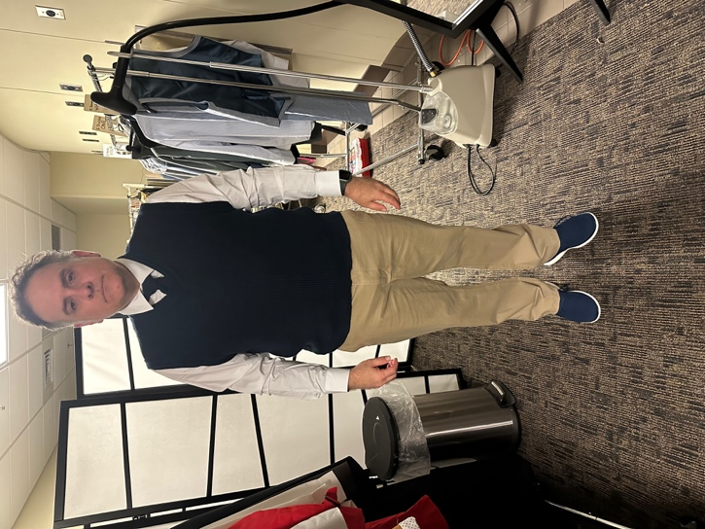
  ITEM | WASH | D.C. | HAND | N/A
  Undershirt (2) | X
  Socks (2) | X
  White Button Up Shirt | X
  Khaki Pants | X
  Blue Shoes |  |  |  | X
  Tie |  |  |  | X
  Belt |  |  |  | X
  Blue Sweater vest |  | X
Chris
 | 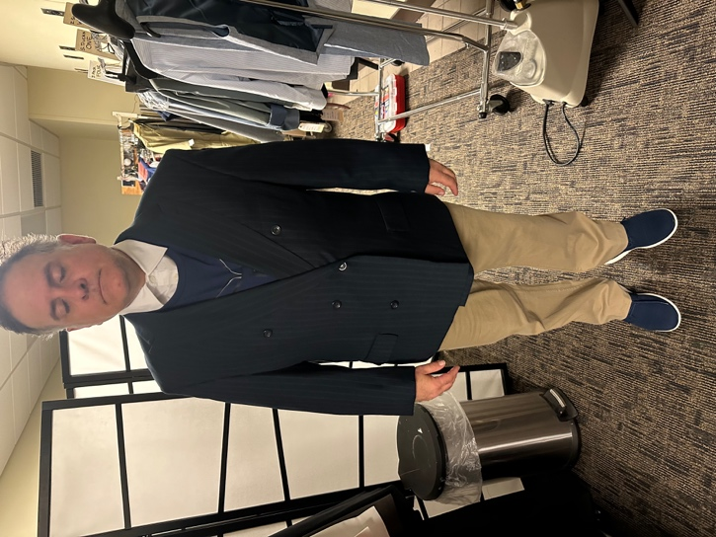
  ITEM | WASH | D.C. | HAND | N/A
  Remove Vest |  | X
  Civil War Shirt | X
  Black Pinstripe Coat |  | X

Nightmare
ITEM | WASH | D.C. | HAND | N/A
Remove Coat |  | X

Kelly
ITEM | WASH | D.C. | HAND | N/A
Remove Civil War Shirt | X

Councilman Vote
ITEM | WASH | D.C. | HAND | N/A
Remove Sweat bands | X
Blue sweater Vest |  | X

End of Show
ITEM | WASH | D.C. | HAND | N/A
Pink Mask | X

